**Projects Requirements**

**Lighthouse**

**Use Cases**

**Describe the sequence of actions a project performs with either a listing or graphic**

App Function #1 – Emotional Journal Log

1. Open app
2. Select emotional journal entry tab
3. Click new entry
4. Fill out prompts
5. Click save, returns to main tab

App Function #2 – View Previous Entries

1. Open app
2. Select emotional overload entry timeline
3. Scroll to a particular entry you wish to view
4. Double tap entry you wish to view
5. Review entry
6. Click return when finished, returns to timeline
7. Click return when finished with timeline, returns to main tab

App Function #3 – Add affirmation

1. Open app
2. Select affirmations tab
3. Click add new affirmation button
4. Fill out new affirmation
5. Click save, returns to affirmation tab

App Function #4 – View Affirmations

1. Open app
2. Select affirmations tab
3. Scroll down to view affirmations
4. Click return when finished, returns to main tab

App Function #5 – Affirmation Notification

1. Open app
2. Select affirmations tab
3. Enable/Disable affirmation notifications
4. Click return when finished, returns to main tab

**System Design**

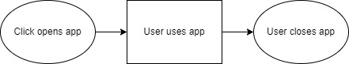

**Technical Requirements**

The application will be built for Android phones, using Android Studio, this application, due to its personal nature does not and will not require any sort of cloud-based data storage, as that feels like it would be a violation of the user’s privacy. At some point in the future, there may be some element of cloud connection for group sharing, but that’s not the base slated features.

So, the technical requirements:

* App must be able to be run locally
* App must be able to persist information from previous runs of the application
* App must be able to push notifications to the user’s phone

**System Logical Model**

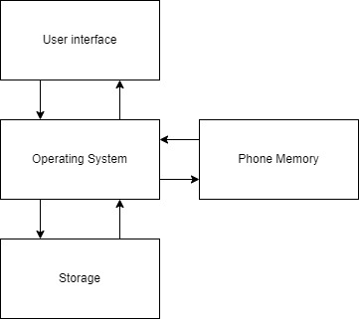

**Reports**

Due to this application being entirely personal in nature, I don’t see the need for any sort of reports to be necessary. Also, due to the fact that there should be no sort of cloud connection, collecting data in the first place will be nearly impossible as it is.

**Screen Definitions and Layouts**

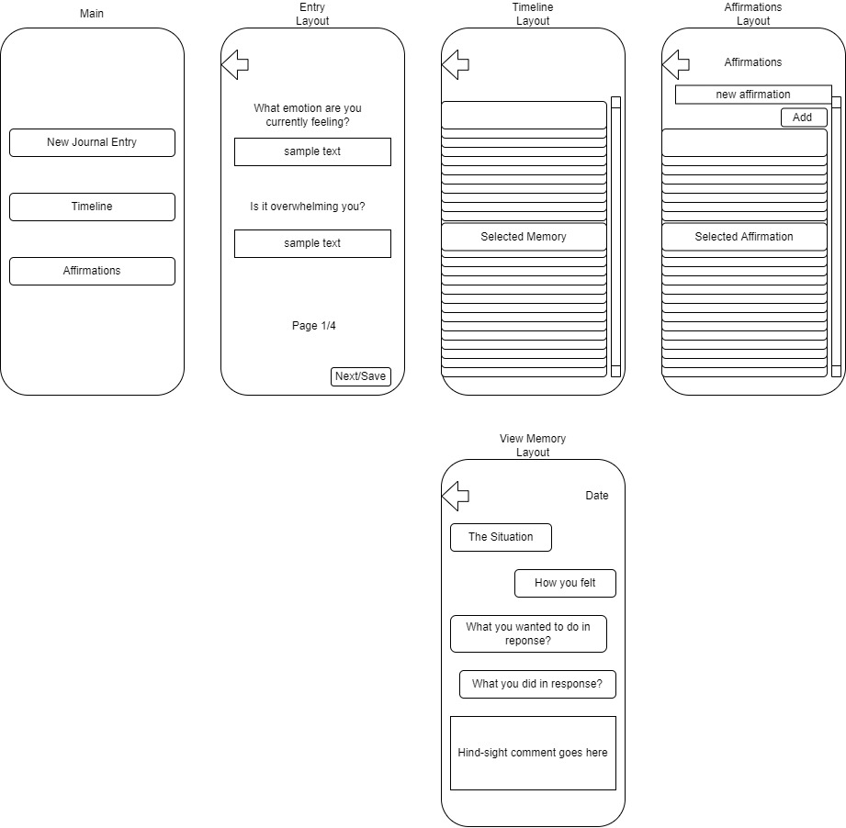

**Security**

Due to this application being location on a user’s phone, stored locally and with no internet connection. There is no need for extra security since the application with already be secured by whatever security the user’s phone has. If they don’t want to secure their phone, why force the user to secure their journal entries? If they did secure their phone, why force them to secure their journal entries again. When feelings are overwhelming you, things need to be simple, and having to remember yet ANOTHER password is just annoying and sometimes stressful, which is antithetical to the purpose of the application, and since there is not technical reason that there should be any sort of security, and fundamentally there doesn’t really seem to be a reason, and nobody else really has access to the application anyways, there will be no forced security measures implemented.

**Other (as dictated by the context and scope of the project)**